**ZombieMiNIR Documentation**

Sarah Hammond, Justin Smith, Duo Gong, Nick Kolesar

Hamilton College

2013

**Requirements:**

1. Only compatible with 64-bit Windows, Java 1.7.
2. Install the Release R2013b (8.2), Windows 64-bit MATLAB Compiler Runtime from the following link: <http://www.mathworks.com/products/compiler/mcr/>

**Start up:**

1. Open ZombieMiNIR.jar.
2. After loading, a file dialog will appear.
   1. Create a new workspace.
      1. Select an empty folder.
         1. Click ‘OK’.

OR

* + 1. Click ‘Make new folder’.
       1. Immediately enter name. (Do not click or arrow away before doing this.)
       2. Click or arrow to a different folder.
       3. Go back to the folder you just made.
       4. Click ‘OK’.
  1. Open an old workspace.
     1. Browse for directory.
     2. Click ‘OK’

**Adding a new subject:**

Input types:

1. ISS File Loading - takes .txt file produced by ISS device
2. Hitachi - takes Hb and or HbO files produced by Hitachi device, in Excel csv format
3. Conditions File:
   1. 2

1 20 1

21 40 2

51 70 1

71 90 2

* 1. First line is the maximum condition number.
  2. Next lines of the form: start stop label
  3. Start-stop ranges must be in order.
  4. Ranges cannot overlap.
  5. Ranges without a condition will be assigned condition 0.

Preprocessing:

1. ISS Oxyplex File Loading
   1. Enter preliminary information.
      1. Give a unique subject name.
      2. Give the number of sessions (data files) for the subject.
      3. Click enter for next step to appear.
   2. Select preprocessing options. (Click cancel to return to first step.)
      1. Browse for data file.
      2. Browse for conditions file. (See above for format.)
      3. Give various frequencies and optional sliding average.
      4. Click ‘Add’ to run preprocessing and add subject to the list of subjects on the left side.
      5. Repeat until all sessions have been entered.

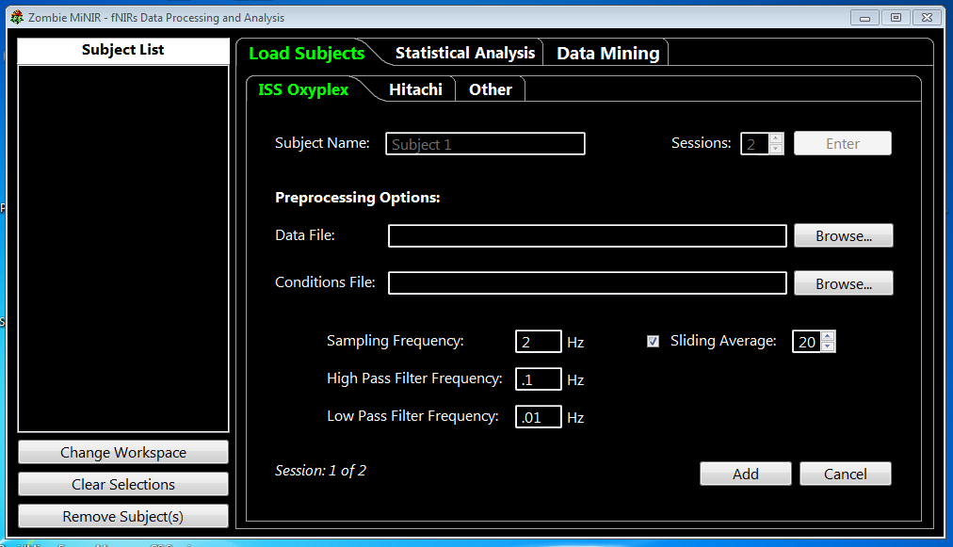

1. Hitachi File Loading
   1. Enter preliminary information.
      1. Give a unique subject name.
      2. Give the number of sessions (data files) for the subject.
      3. Give the number of channels that the data file(s) contain. (Default 52 for Hitachi)
      4. Select Hb/HbO to mark whether you are entering only one type or both.
      5. Click enter for next step to appear.
   2. Enter file names. (Click cancel to return to first step.)
      1. Browse for Hb File/HbO File.
      2. Browse for conditions file. (See above for format.)
      3. Click ‘Add’.
      4. Repeat step b until all sessions have been entered.

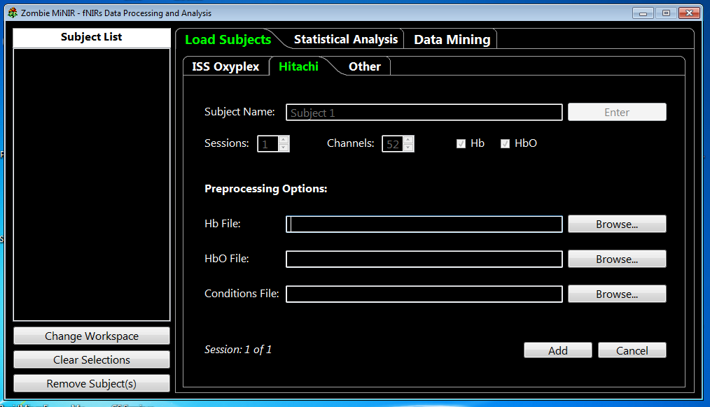

1. Other File Loading
   1. Enter preliminary Information.
      1. Give a unique subject name.
      2. Give the number of sessions (data files) for the subject.
      3. Select Hb/HbO to mark whether you are entering only one type or both.
      4. Click enter for next step to appear.
   2. Enter file names. (Click cancel to return to first step)
      1. Browse for Hb File/HbO File.
      2. Browse for conditions file. (See above for format.)
      3. Click ‘Add’.
      4. Repeat step b until all sessions have been entered.
2. File loading on any tab will create a folder in the ‘subjects’ folder of the workspace.
3. This folder will contain the conditions file, and the Hb and HbO Files if they have been loaded.

**Removing Subjects:**

1. Select subject(s) from the Subjects list that you wish to remove.
2. Click ‘Remove Subject(s)’.

**Changing to a different workspace:**

1. Click change workspace.
   1. Create a new workspace:
      1. Select an empty folder.
         1. Click ‘OK’

OR

* + 1. Press ‘Make new folder’.
       1. Immediately enter name. (Do not click or arrow away before doing this.)
       2. Click or arrow to a different folder.
       3. Go back to the folder you just made.
       4. Click ‘OK’.
  1. Open an old workspace.
     1. Browse for directory.
     2. Click ‘OK’

**Statistical Analysis:**

1. Load groups and conditions.
   1. Select one or more subjects from the list on the left.
   2. Select a valid channel groupings file, in the following format:
      1. groupOne 1 2 3 4

secondGroup 5 6 7 8

groupThree 1 2 3 4 5 6 7 8

group4 1

g5 1 2

* + 1. Grouping name followed by the channel numbers in the group
    2. Channels start from 1
    3. All separated by spaces or tabs.
    4. Separate groups on different lines.
  1. Select the type of data to analyze:
     1. Oxygenated/HbO
     2. Deoxygenated/Hb
     3. Both
  2. Click ‘Load Groups and Conditions.’
     1. The group names from the groups file and the condition numbers from preprocessing will be displayed.

1. Calculate p-values.
   1. Select the channel groupings and conditions you wish to analyze.
   2. Enter the number of values the data sets that will be analyzed should have in the ‘Chunks’ box.
      1. The data will be divided into this many chunks and the all the data in each chunk will be averaged together to produce an average value for the chunk.
   3. Enter the number of decimal places the ANOVA output values should have (Note that these are not significant digits, and the output values will not be accurate after an unknown number of decimal places.)
   4. Enter the name of the output directory.
      1. This will be a subdirectory of the workspace's ‘stats’ folder and will contain Hb and/or HbO files depending on your selection.
   5. Click ‘Compute P-values’ to write the .csv files to the output directory.
      1. These files can be opened by Excel.
      2. They are organized as follows: the p-value for a given combination of group/condition pairs is located in the cell whose column and row labels are those group/condition pairs. That is, the table contains two copies of each p-value, except those lying on the diagonal, which result from taking a p-value between a data set and itself. Think of the group-condition identifiers as x and y coordinates if that helps. Also, note that condition numbers are preceded by the letter 'c'.

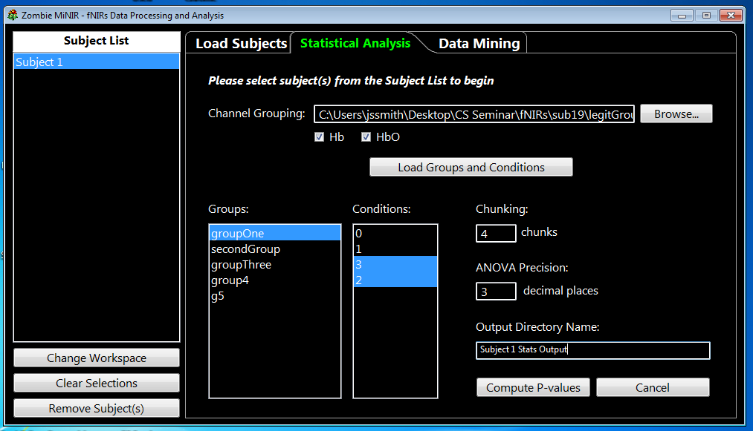

**Data Mining:**

1. Fill the ‘Conditions’ list.
   1. Fill in the ‘Subject Name’ text box with the name of a subject by either clicking on its name in the list or typing it in.
   2. Select the Hb/HbO check boxes to select only the Hb file, only the HbO file, or both.
   3. Click ‘Fill Conditions.’
2. Run a Data Mining process through RapidMiner.
   1. Select at least two conditions.
   2. Select a process template.
   3. Select a data representation.
      1. Fill in the required parameters.
   4. If you do not want the output file to be given the same name as the subject, change the ‘Output File Name.’
   5. You can access the RapidMiner output by going to the dmining folder in your workspace and opening the file with the name entered in ‘Output File Name.’
3. Creating New Process Templates from RapidMiner
   1. Process must read input via Read Excel operator
   2. Process must write output via Write Excel operator
   3. Convert output to Example Set then send to Write Excel
   4. Input comes in the form:
      1. (n-1) true.real.attributes followed by 1 true.polynominal.label
   5. Replace

      <list key="data_set_meta_data_information">

         <parameter key="0" value="1.true.real.attribute"/>

    .

     .

    .

         <parameter key="n" value="label.true.integer.batch"/>

       </list>

With #!#TEMPLATE#!#

* 1. Save the template in the ‘dmining/templates’ folder in the workspace

